**Phase-3**

**Third Increment**

**Project Restaurant Finder**

**&**

**Diet Planner**

**Group #13**

Katta Nikitha

Dandamudi Naga Mounika Goli Venkata Govardhan

**CONTENTS**

**I. Introduction**

**II. Project Goal and Objectives**

Overall goal

Specific objectives Specific features Significance

**III. Project Plan**

Issues

Burn Chart

Graphs of team member’s contribution

**IV. Third Increment Report**

Detail Design of Features Implementation

Deployment

Project Management

Bibliography

**I. Introduction:**

Restaurant Finder application is an android based application with an objective of finding restaurant based on the requirement which are location and the cuisine details entered by the user. The locations of various restaurants with their basic services available and the daily specials. By this application the user not only can locate the restaurants that are nearby and also can make choice of best restaurant based on the rating.

This application let the user view the menu in the restaurants nearby and also the nutrition value offered by the items in the menu. Health diet is important for prevent any health issues. Health Issues occur due to malnutrition which is caused due to nutrition imbalance or excessive intake of junk food. It is important for us to know the nutrition value of the food we eat, and also to

What extent it is meeting the daily requirement. The main aim here in this application is to let the user find a best restaurant of his/her choice based on their location and cuisine requirements and can also know the nutrition value of the food they want to eat and can also know to how much they are meeting their daily nutritious requirement.

**II. Project Goals and Objectives:**

**Over- All Goal:**

1. The main goal of Restaurant Finder application is to find the information about the location of various restaurants near our location.

2. The route to these restaurants and their basic services available.

3. The list of items and their costs or the menu in the restaurant and also their daily specials.

4. The nutritional value and calorific value of the items in the menu.

5. Compare the nutritional value of the intake food with the available standard per day intake of different type of nutrients.

**Specific objectives:**

1. The user can locate the restaurants nearby his location and routes to these restaurants.

2. The user can also view the menu or the list of items with their cost.

3. Suggest the items with high nutritional and calorific value.

4. Analyze the nutritional value of the food we eat with the standard per day intake of nutrients.

**Specific Features:**

1. Location and directions to the restaurants depending on our requirement of type of cuisine.

2. Suggesting the food with high nutritional and calorific values best suited.

**Significance:**

1. The user can make a choice of best restaurant depending on his location and the type of food he like.

2. Can maintain healthy diet by suggest the food with high nutritional and calorific value.

**III. Project Plan:**

**Issues:**

1. Data base connection

2. Maps Activity

3. Layouts

4. Testing

5. Register

6. Sign Up

7. Personal Information

8. Design of project

a) Use Case Diagram b) Sequence Diagram

c) Wire Frame

d) Class Diagram

**Burndown Chart**

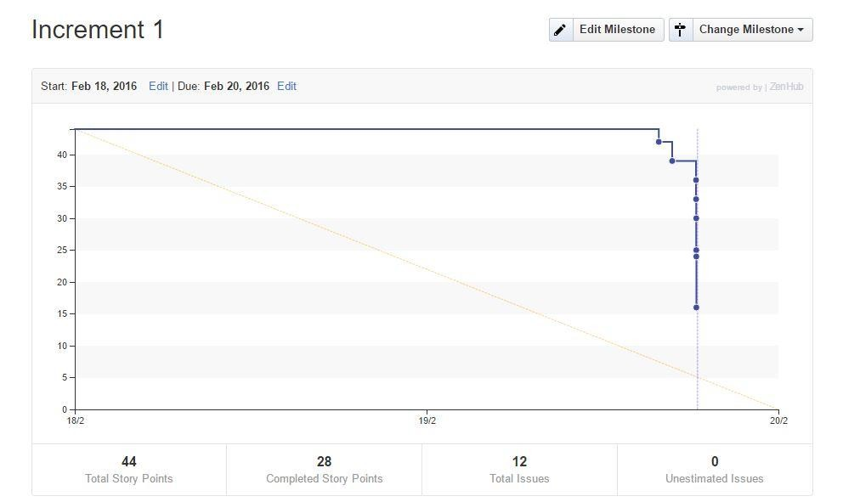

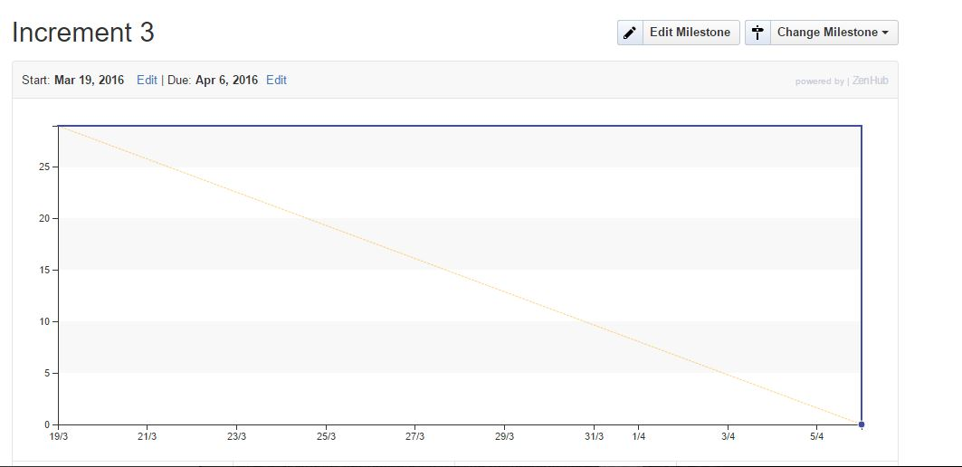

**Graphs for contribution of all the team members:**

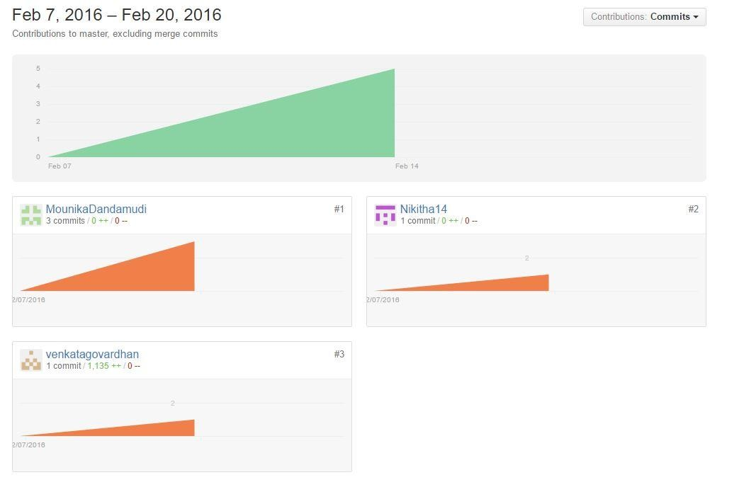

This are the graphical representation of the completed stories to the uncompleted stories of the issues which are created during the project first increment. The below graphs are the contributions made by the us during this first increment.

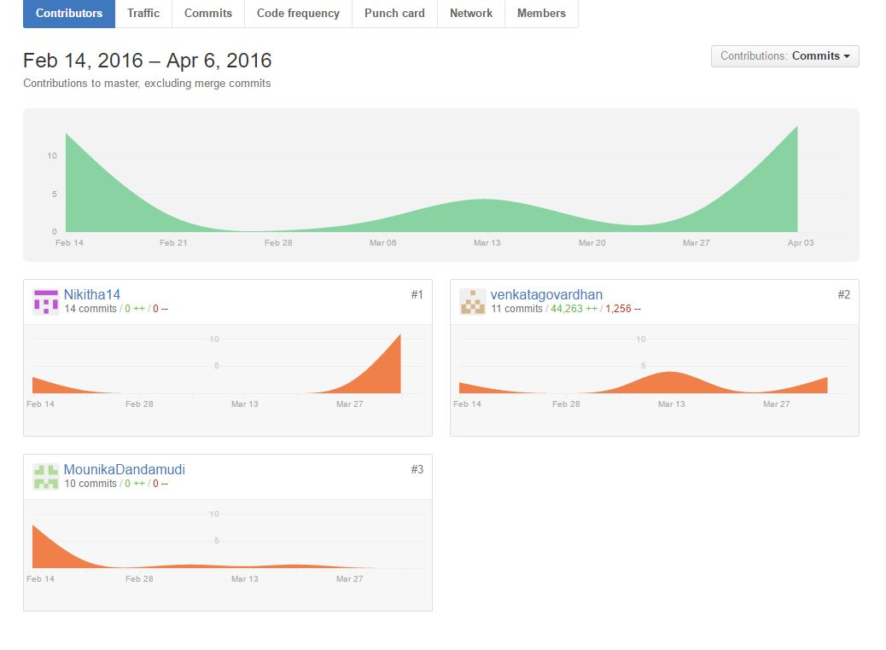

This are the graphical representation of the completed stories to the uncompleted stories of the issues which are created during the project third increment. The below graphs are the contributions made by the us during this third increment.

**IV. Third Increment Report:**

As a part of first Increment we created Login, Register, Personal Info and Home page for the users. Any user can access Restaurant finder by login or registering in with their personal info.

A new user after registering with their personal info, can login by their entering their username and password and enter into Restaurant finder application. After login the user's current location can be pointed out using the existing Network Provider. The restaurants nearby user location can be pointed. On selection of the restaurant the direction to drive from our location can also be obtained.

The user can enter the nutrient database food number and get the protein, carbohydrate by difference, calcium, Energy iron fiber and total dietary. The user can chose the food which have high calorific value.

Diet Planner is implemented in this increment, a special feature is provided which is Body mass Index (BMI). In this user can input the height and weight and gender and BMI value is calculated and displayed.

**Existing Services/API:**

Restaurant Finder application uses API’s like Google Maps API, Location Services API which are already existing and SQLite to store data.

We have used Location services API and we are also working on Google Maps API. In Location Service API, our location is pointed out after login. SQLite is a software library that implements server less.

In this increment Google Maps API is called to get the directions from our location to selected restaurant and Food API which is United states Department of Agriculture (USDA) is called in diet planner to get the nutritious value of the food. The user can get the protein, calcium, iron and fiber content in the food.

**Detail Design of Features:**

**Wireframes:**

We have designed a basic login page for the users to access their account in a secure way.

The details of the users are stored in the SQLite.

We have designed a basic registration page for the users to create their own account to store all the details so that they can access their data where they want.

We have designed a personal Information page for the users to find their interested food and cuisine so that we can search the restaurants based on their information provided.

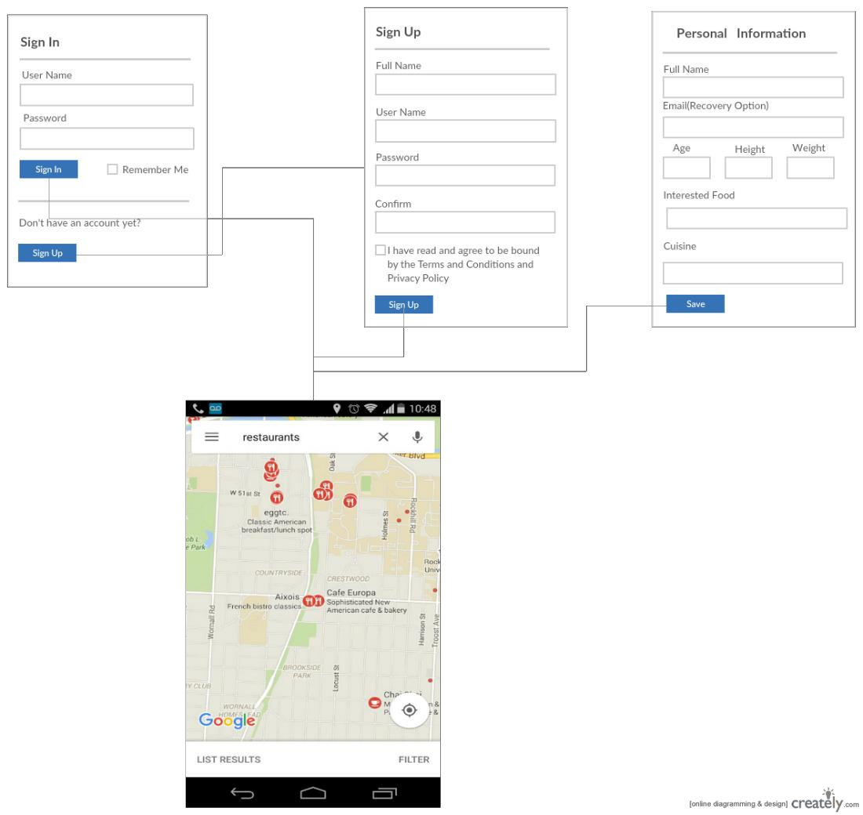

**Sequence diagram:**

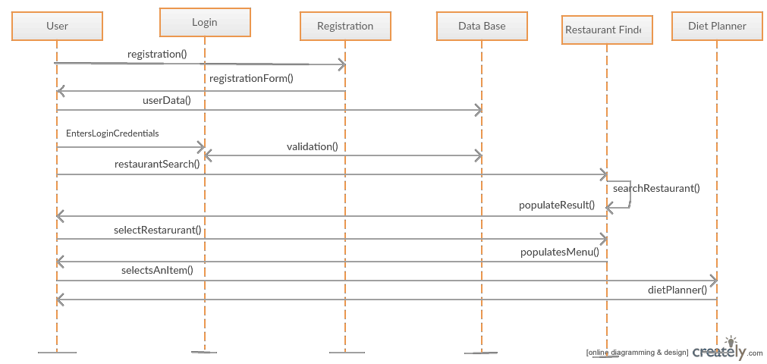

Sequence diagram represents the flow of the application processes done by the different persons. In the initial state user open the application, the application get the data form the database and view in the dashboard. With the personal information provided by the user and also by keyword search, we find the top restaurants for the search. After which we provide the menu of the restaurants and address and directions to drive to reach to the selected restaurant.

We keep a track of the food intake of the user in the past days and suggest to take food to compensate the nutritious requirement of the body.

**Class diagram:**

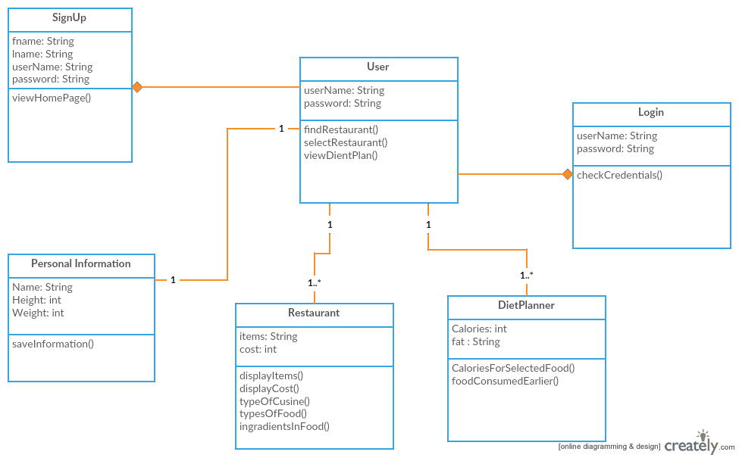

In design phase we have designed the general flow of the state of the user and the application. Structure of the data to be created is designed and represented as the following class diagram. Restaurant Finder application consists of 5 classes User, Sign up, Login, Personal information, and Restaurant and Diet planner.

User operations are to give information or specifications required and select the restaurant depending on the distance from the location or the requirements and view the diet planner and follow the details.

Restaurant class consists of the items to display, cost of the items and types of food and any more specials that are offered that day.

Diet Planner class give display the calories of the intake food and the nutritious value consumed and select the items to compensate the nutritious requirement of the body depending on the body and weight details given in the personal information.

**Use Case diagram:**

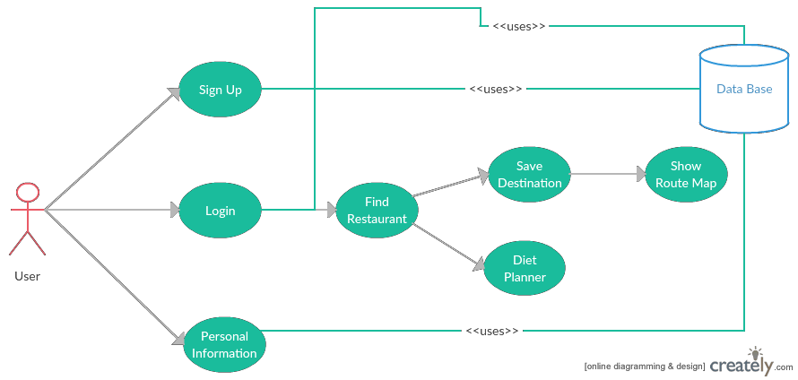

Use case diagram provides the sequence of operations that take place in the application. In the initial state user open the application, the application get the data form the database and view in the dashboard. With the personal information provided by the user and also by keyword search, we find the top restaurants for the search. After which we provide the menu of the restaurants and address and directions to drive to reach to the selected restaurant.

We keep a track of the food intake of the user in the past days and suggest to take food to compensate the nutritious requirement of the body.

**Implementations:**

**Restaurant Finder:**

Restaurant Finder app consists of Login page, Register Page and personal info and Home page are created in android studio. Personal info of users is stored using SQLite. Using Location API the current location of the user is pointed out. With the personal information provided by the user and also by keyword search, we find the top restaurants for the search.

Using Google Maps API the user can get the direction to go by car or bus or by walk to the selected restaurant.

After which we provide the menu of the restaurants and address and directions to drive to reach to the selected restaurant.

**Diet Planner:**

The diet planner is implemented by providing a special feature by calculating the BMI value which can be obtained on giving the height, weight and gender of the user as inputs.

Food API which is United states Department of Agriculture (USDA) is called in diet planner to get the nutritious value of the food. The user can get the protein, calcium, iron and fiber content in the food.

The user can enter the nutrient database food number and get the protein, carbohydrate by difference, calcium, Energy iron fiber and total dietary. The user can chose the food which have high calorific value.

We keep a track of the food intake of the user in the past days and suggest to take food to compensate the nutritious requirement of the body.

**Deployment:**

Restaurant Finder application is deployed on mobile and explained in the below screen shots.

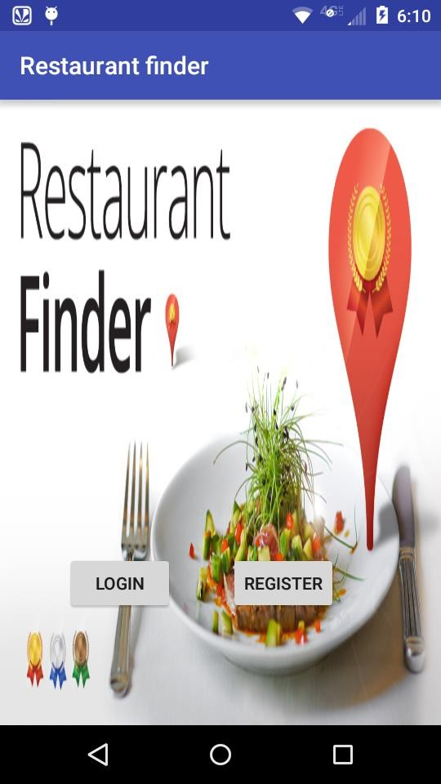 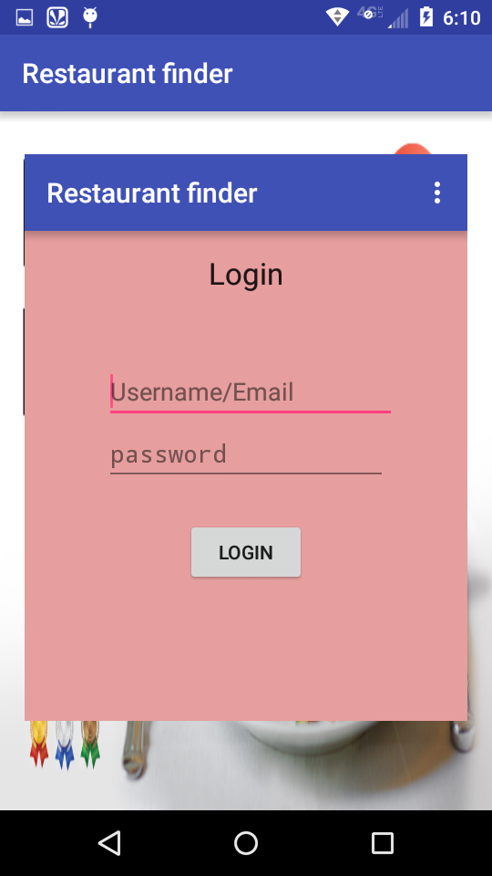

Login page of this restaurant finder app consists of Username/email and password, if the details of user are given then we can get the location of the user.

A new user has to first register to access this app, the register page or sign up consists of the personal info of the user, which on entering the info by the user we can login to the app by username/email and password.

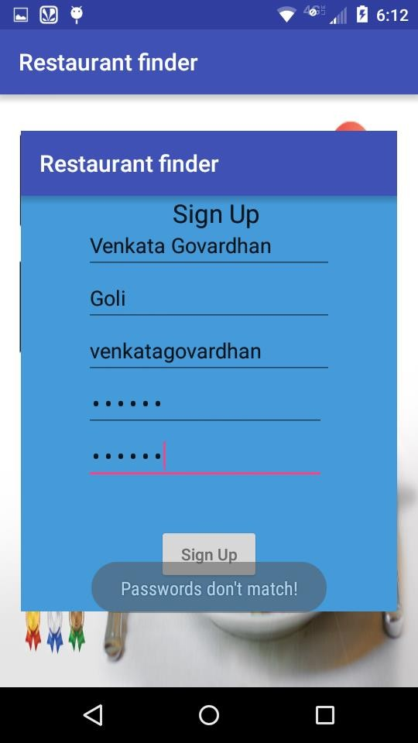 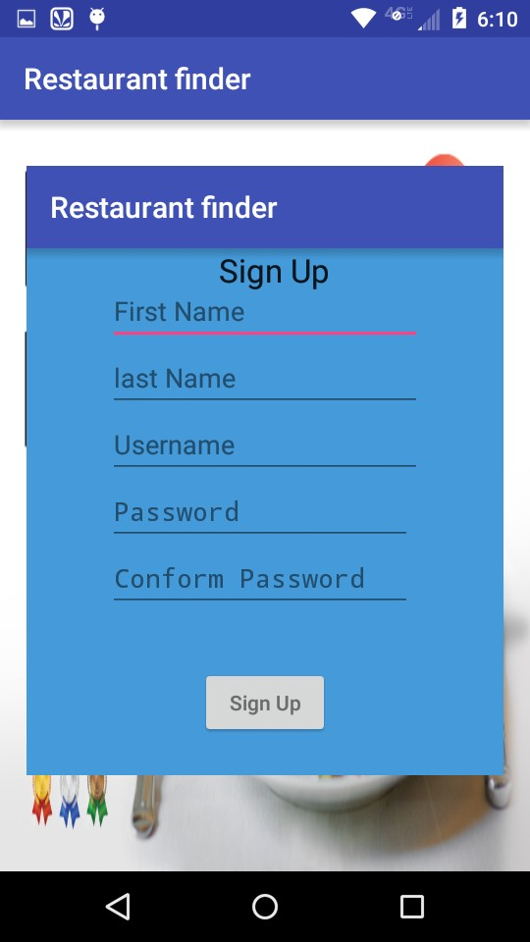

The signup page consists of details of the user which on entered get logged in. The details of the users are being stored and after signup these details can be used for login to access the restaurant finder app.

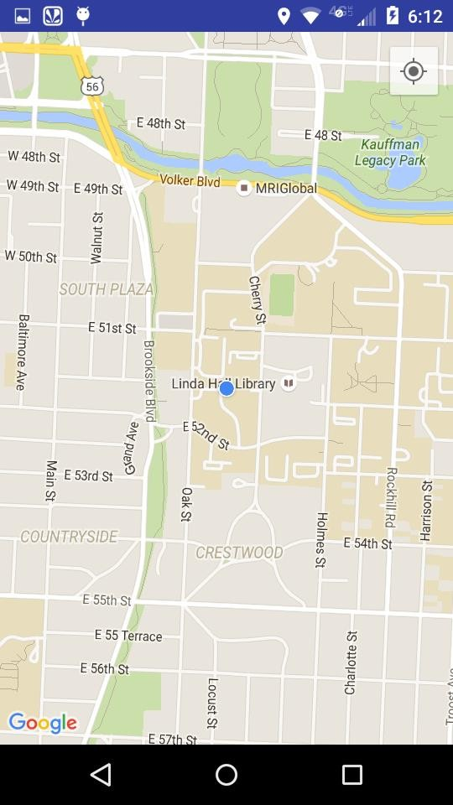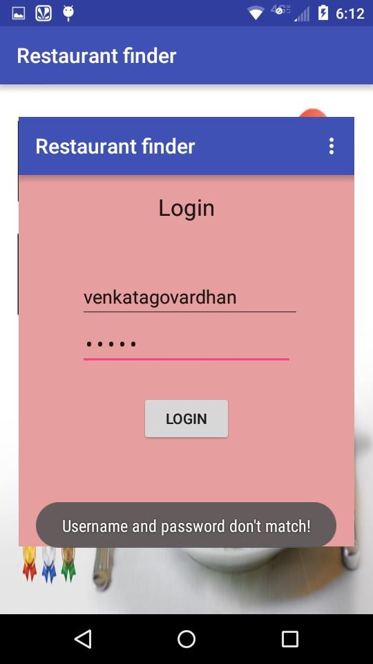

On logging in the current location of user is displayed using location API. With the personal information provided by the user and also by keyword search, we find the top restaurants for the search. After which we provide the menu of the restaurants and address and directions to drive to reach to the selected restaurant.

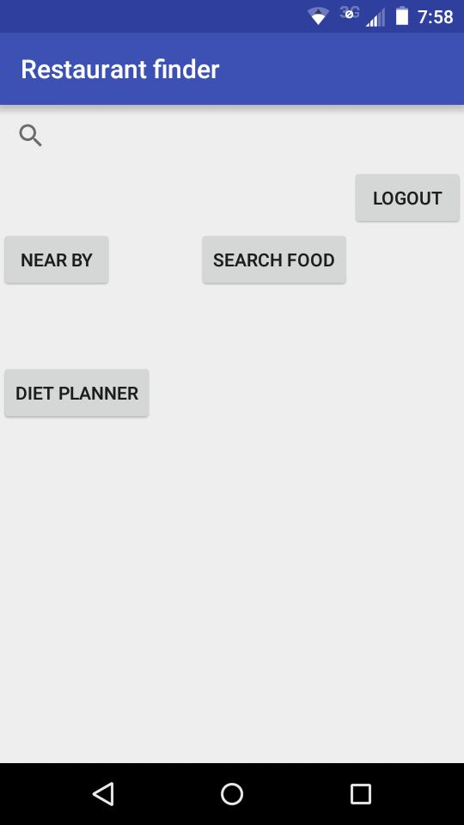

This is the home page here we can select the desired location to search for the restaurants.

On clicking the nearby button, nearest restaurants will pop up. We can also search the food type on clicking search food where the restaurants serving those food would be displayed.

Diet planner can also be integrated with restaurant finder app where by the BMI value of the user can be displayed by giving the height, weight and the gender of the user. The nutritious value of the food can also be obtained using diet planner.

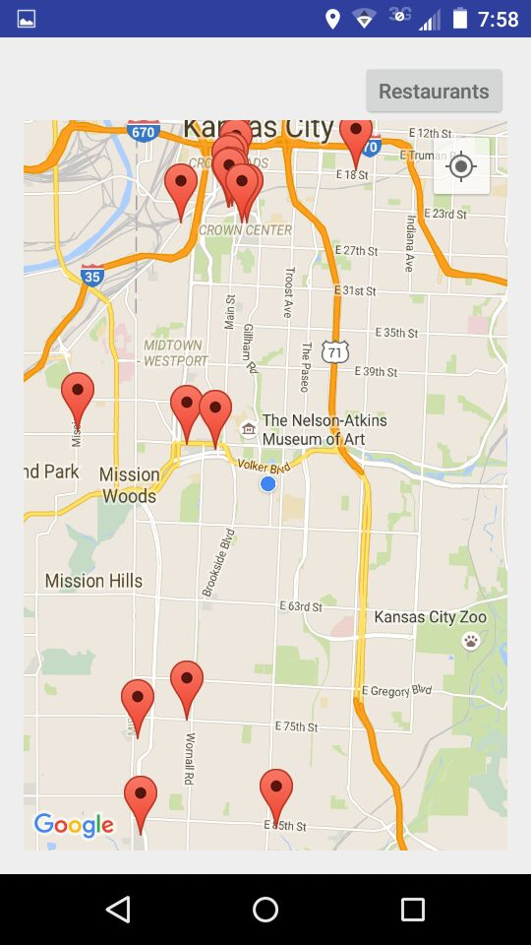 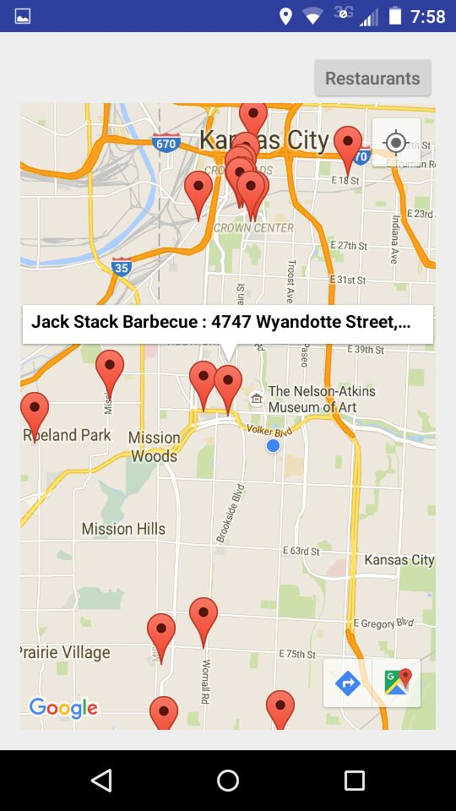

The nearest restaurants are poped up as shown in the screen shot. Using Location API the current location of the user is pointed out and on clicking nearby the restaurants nearby are popped up. We can select any restaurant of our choice and get directions to go to that restaurant.

Using Google Maps API we get the direction to go by car or bus or by walk to the selected restaurant.

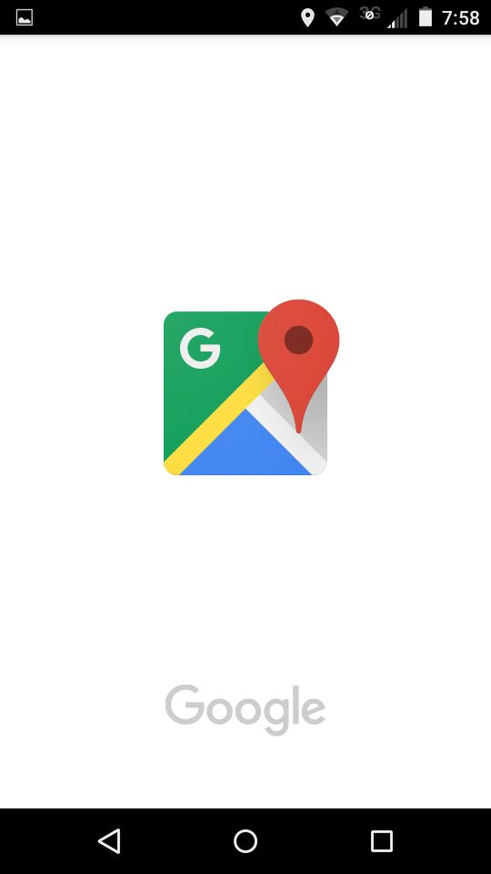 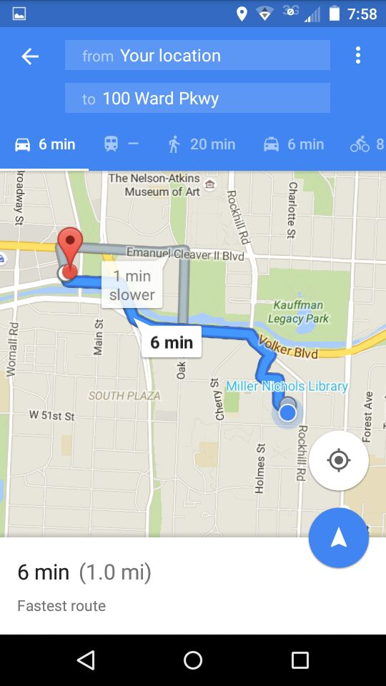

Using Google Maps API we get the direction to go by car or bus or by walk to the selected restaurant.

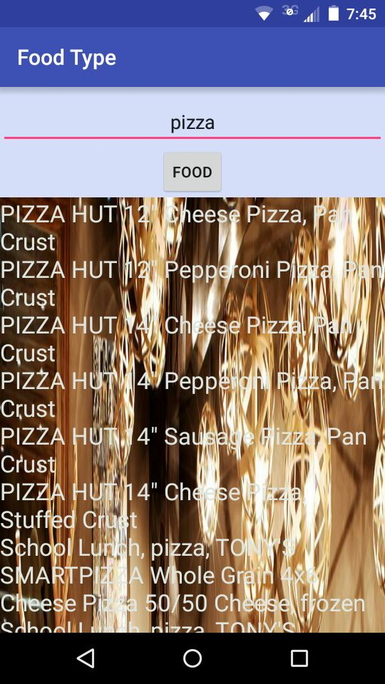 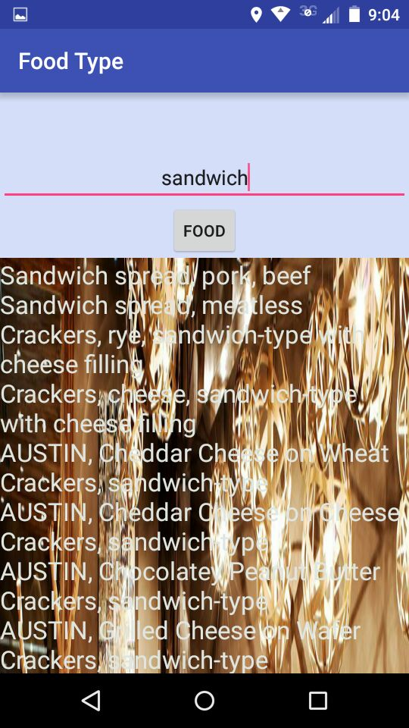

In restaurant finder app there is a search food button on the home page, we can search different food types. Above are the screens shots for two different types of food type we searched. We can select the places which serves our selected food type. Here we called one of the Food API which is United states Department of Agriculture (USDA) to get the places which serve the searched food type.

**Diet Planner:**

The **Diet Planner** webapplication is to develop an application which contains database comprising of nutritional value, calorific value, protein value, fat content, fiber content , vitamins present in particular food item which user can input the food.

The main modules in this application are BMI chart and Nutritional chart

It calculates BMI (Body Mass Index) for users. For calculation user need to provide two inputs i.e. weight (in kgs) and height (in cms). Based on the inputs, BMI is calculated and displayed on the same screen with the status of a person.

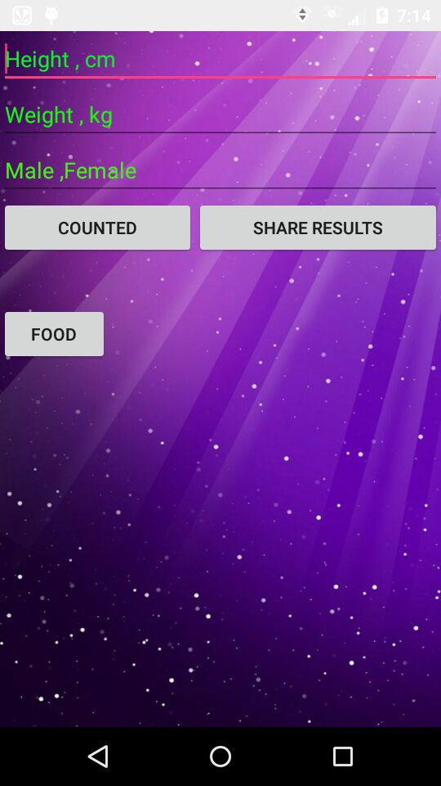 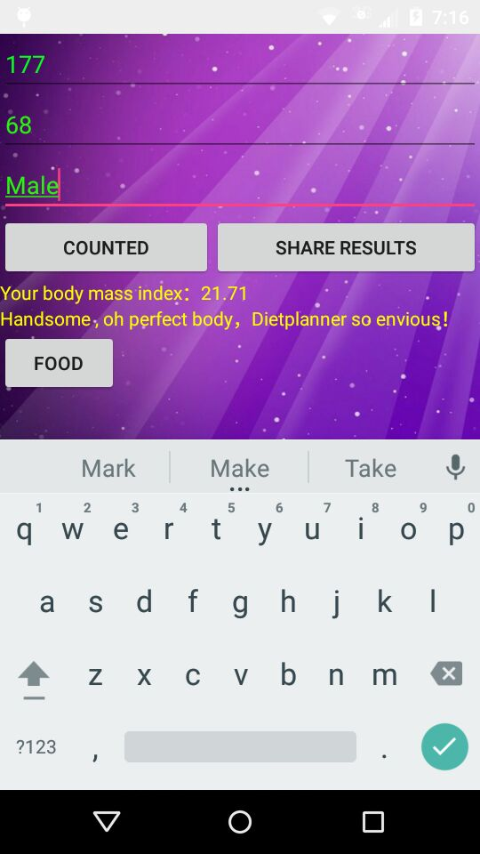

This BMI result can be shared with the friends via social networking sites like google plus or Facebook or chatting applications like WhatsApp etc. We can share and ask them to try this and know their BMI values and their fitness.

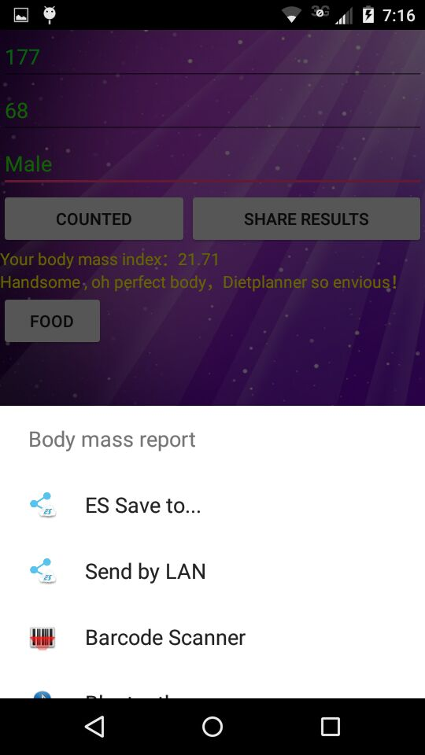 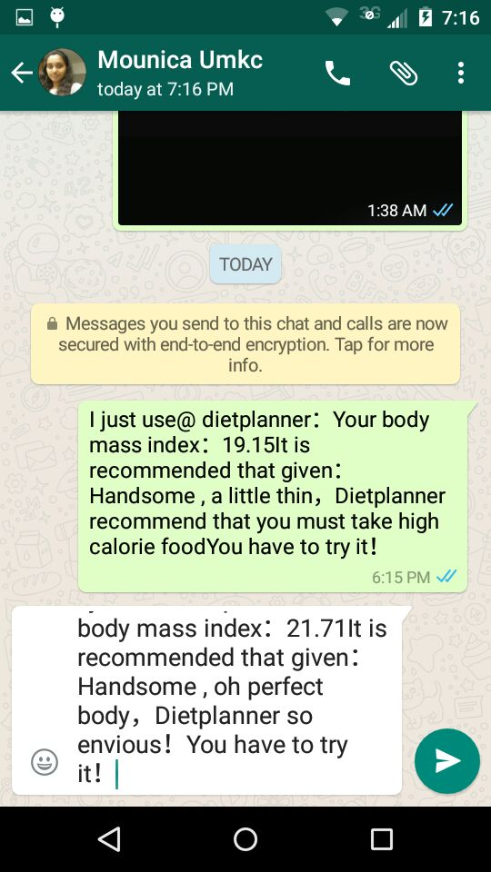

We can find out Body mass Index (BMI) and it recommend us to take the food with required calories so that we can have fit body. And also share this result with friends as shown in the screen shots above.

Nutrition chart in this application is a static page which contains information about the food items available. The information here contains all the nutritional data like protein, carbohydrate by difference, calcium, Energy, iron and Fiber content.

Food API which is United states Department of Agriculture (USDA) is called in diet planner to get the nutritious value of the food.

The user can enter the nutrient database food number and get the protein, carbohydrate by difference, calcium, Energy iron fiber and total dietary. The user can chose the food which have high calorific value.

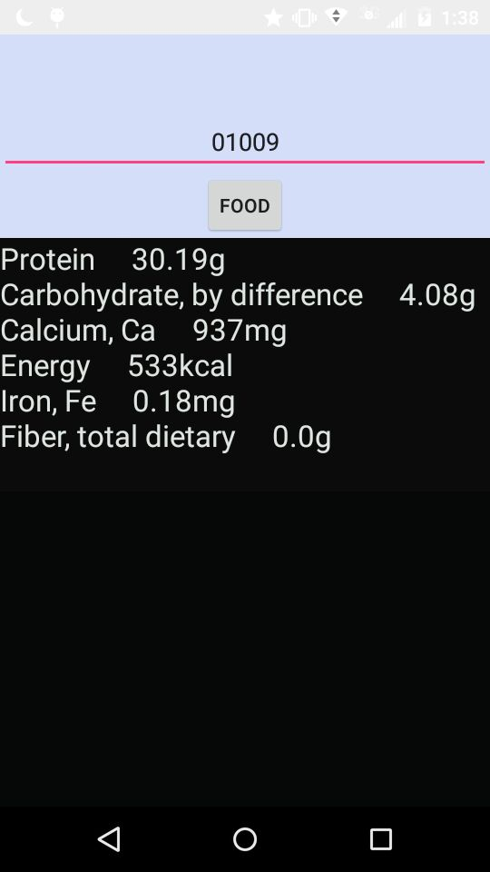

**Project Management:**

**Work completed:**

Basic design phase using class diagram, Sequence diagram and Use case diagram is completed. The application basic design view phase using wireframes is completed.

The restaurant finder app's basic design-home, login, register and personal info pages are created. The personal info of the users are stored using **SQLite**. Location API is used to find the user present location. Google places API is used to find the nearby places. Using Google Maps API the user can get the direction to go by car or bus or by walk to the selected restaurant.

The diet planner is implemented by providing a special feature by calculating the BMI value which can be obtained on giving the height, weight and gender of the user as inputs.

Food API which is United states Department of Agriculture (USDA) is called in diet planner to get the nutritious value of the food. The user can get the protein, calcium, iron and fiber content in the food.

The user can enter the nutrient database food number and get the protein, carbohydrate by difference, calcium, Energy iron fiber and total dietary. The user can chose the food which have high calorific value.

We keep a track of the food intake of the user in the past days and suggest to take food to compensate the nutritious requirement of the body.

**Work to be completed:**

Call to restaurant API has to be made.

In Diet planner, diet chart has to be implemented, the user can select the food items that he has taken and can compare with daily standard requirements of nutrition .If the food items selected have less nutrition then the standard one application suggests the users to take more nutrients.

**Bibliography:**

[https://console.developers.google.com](https://console.developers.google.com/)

<http://developer.android.com/tools/studio/index.html>